2.5 Deploying semantic models (XMLA endpoint)

Key points
- The XMLA endpoint is a way to connect your fabric workspace with third-party tools. You can find the XMLA endpoint address in the Workspace Settings.

- You can use the XMLA endpoint to deploy semantic models, from third-party tools, into your Fabric workspace.

- All Fabric workspaces have an XMLA endpoint, regardless of your capacity (this is unlike the old Power BI model where only Power BI Premium workspaces had an XMLA endpoint connection).
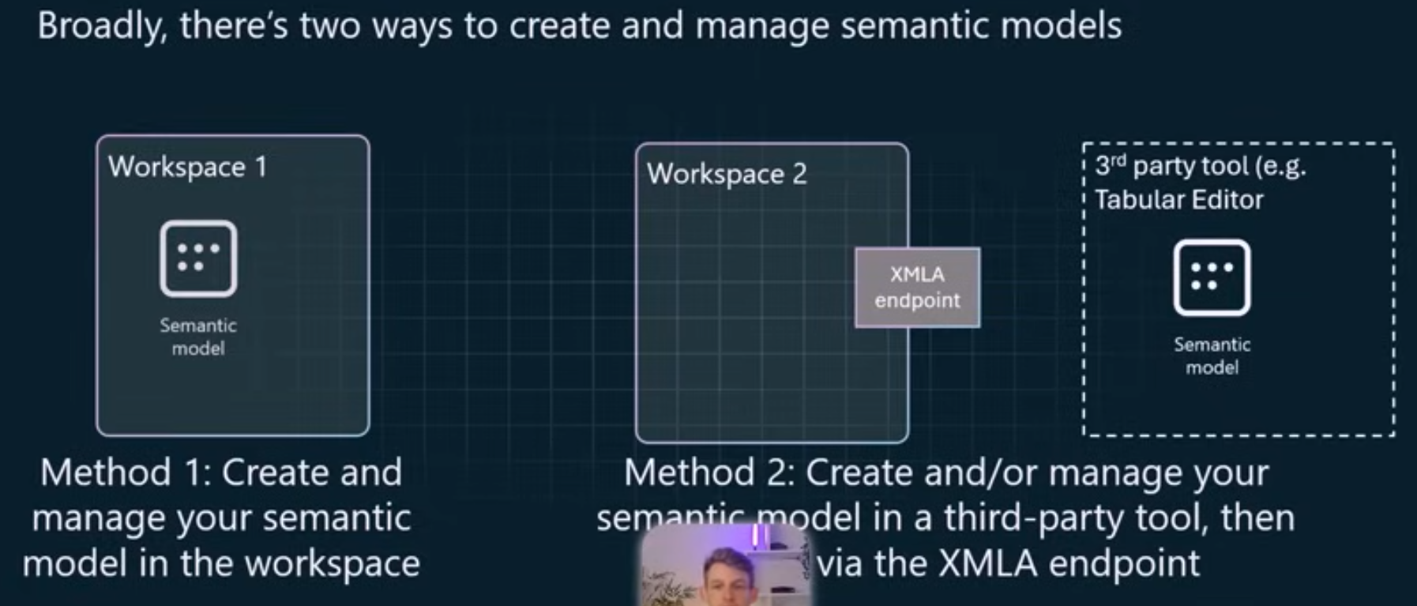

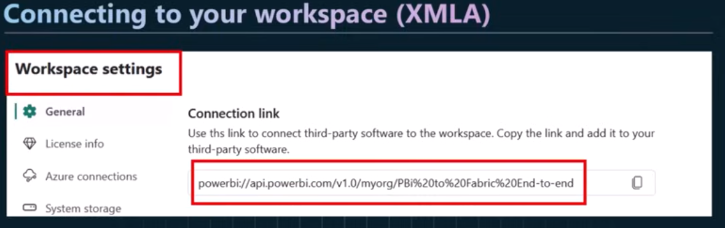

s

